3/20/2026

User Manual
Alex Wilcox
Alina Zimavaya
Crawford James
Luke Fixari

‘ctrlC+ctrlV’

Table of Contents
User Manual 1
1. Installation Manual 5
System Requirements 5
Installation Steps 5
First-Time Startup Behavior 6
Accessing the System 6
Stopping and Restarting 7
Summary: 7
2. Login 7
How to Log In 8
3. Home Page 9
Navigation Menu (Left Sidebar) 9
System Status Panel 10
Flight Information Panels 10
Feature Cards (Main Actions) 11
Departures Table 12
4. Search Flights 12
How to Search for Flights 13
5. Flight Status 15
How to Check Flight Status 15
6. Timetable 17
How to Use the Timetable 17
Flight Information Displayed 19
7. Simulation 19
Overview 19
Simulation Controls 20
Day-by-Day Results 20
Event Log 20
8. Admin Dashboard 21
Overview 21
Live Operations Panel 22
Next Departures 22
Data Management Tabs 22

Table of Tables

Table 1: System URL 6

Table of Figures
Figure 1: Login 7
Figure 2: Login Error Handling 8
Figure 3: Home Page 9
Figure 4: Feature Cards 11
Figure 5: Departures Table 12
Figure 6: Search Flights 13
Figure 7: Search Flights Results 14
Figure 8: Search Flights No Results 14
Figure 9: Flight Status 15
Figure 10: Flight Status Results 16
Figure 11: Flight Status No Results 16
Figure 12:Timetable 17
Figure 13:Timetable Results 18
Figure 14: Simulation 19
Figure 15: Admin Dashboard 21
Figure 16:Users Data Management Tab 22
Figure 17: Aircraft Data Management Tab 23
Figure 18: Airports Data Management Tab 24

Installation Manual

This section provides step-by-step instructions for installing and running the Panther Cloud Air (PCA) system locally.

System Requirements
Before installation, ensure the following software is installed:
- Docker (with Docker Compose)
- Node.js (version 20 or higher)
- Python (version 3.12 or higher)
- Git
Docker must be running before starting the system.

Installation Steps
Clone the Repository
Download the project from GitHub:
git clone https://github.com/AlexJohnWilcox/pca.git
cd pca

Start Docker
Ensure Docker is running:
- macOS / Windows: Open Docker Desktop
- Linux:
sudo systemctl start docker

Initial Setup
Run the setup command to install dependencies and build the system:
make setup
This step:
- Installs frontend dependencies
- Builds backend and database containers
Start the System
Run the following command to launch all services:
make start
This starts:
- Database (MariaDB)
- Backend API (Flask)
- Frontend (React + Vite)

First-Time Startup Behavior
On initial startup, the system will automatically:
- Create an admin account
  - Username: admin
  - Password: pca
- Generate the full flight timetable (~15 seconds)

Accessing the System
Once running, access the application through:
Component | URL
Frontend | http://localhost:3000
Backend API | http://localhost:5000/api/health
Table 1: System URL

Stopping and Restarting

Stop all services:
make stop

Restart services:
make restart

Summary:
The installation process consists of:
- Cloning the repository
- Running setup
- Starting services with Docker
- Accessing the system via localhost
This setup ensures all components (frontend, backend, and database) run together in a consistent environment.

Login

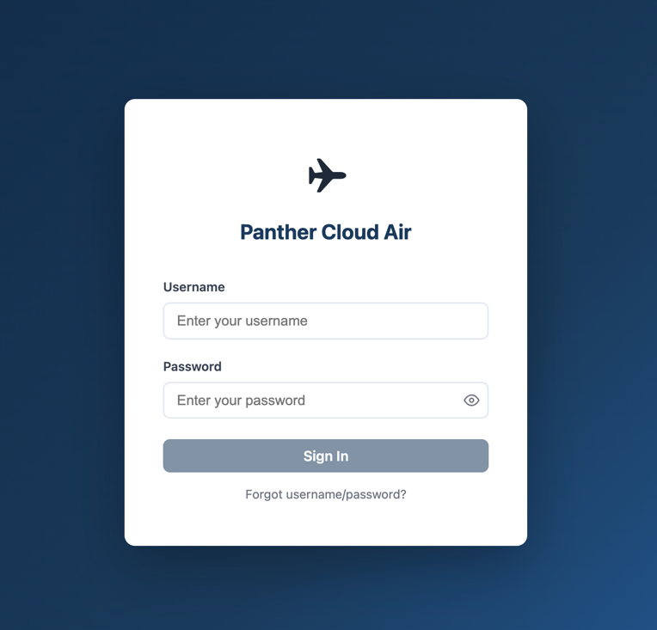
Figure 1: Login

The Login page allows users to securely access the Panther Cloud Air system.

How to Log In
Enter Credentials
Users must enter:
- Username
- Password
Password input is masked for security, with an option to toggle visibility.
Submit Login
- Click the Sign In button to access the system

Error Handling
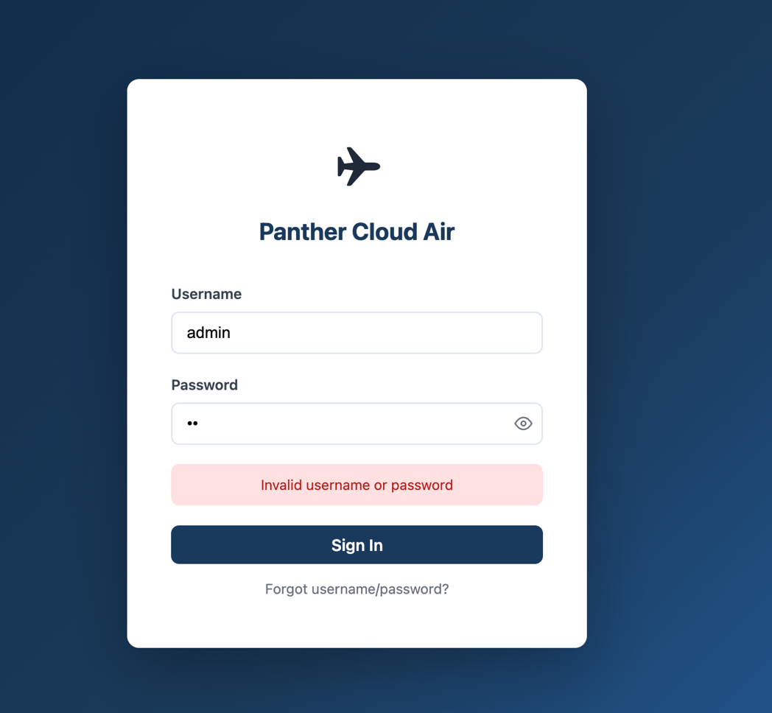
Figure 2: Login Error Handling
If incorrect credentials are entered:
- The system displays: “Invalid username or password”
- Access is denied until valid credentials are provided
Additional Features
- Forgot username/password? link allows users to initiate account recovery
- Login fields must be completed before submission
Usage Notes
- Users must have an active account to log in
- Multiple failed attempts may trigger account restrictions (based on system rules)

Home Page
The Home Page serves as the central dashboard for the Panther Cloud Air system. It provides users with a quick overview of airline operations, access to key system features, and real-time flight information.
When users log in, they are presented with a summary of current operations, including flight activity, system status, and navigation options.
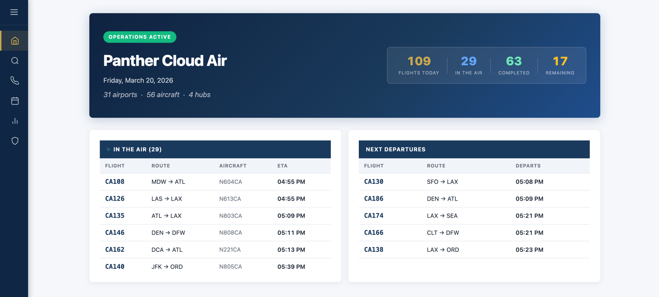
Figure 3: Home Page

Navigation Menu (Left Sidebar)
The left-hand sidebar provides access to all major system features.
- Home – Returns to the main dashboard
- Search Flights – Search for available routes and fares
- Flight Status – View real-time status of flights
- Timetable – View the full flight schedule across all routes
- Simulation – Access simulation data, delays, and performance metrics
- Admin Dashboard – Manage users and monitor system operations (admin access only)
This menu is always accessible and allows users to navigate the system efficiently.

System Status Panel
At the top of the Home Page, users will see the Operations Status Panel.
Key Information Displayed:
- Current Date
- Total Airports (31 airports)
- Total Aircraft (fleet size)
- Number of Hubs
Flight Metrics:
- Flights Today – total scheduled flights for the day
- In the Air – flights currently in progress
- Completed – flights that have already arrived
- Remaining – flights yet to depart
This section allows users to quickly understand the overall state of airline operations at any given time.

Flight Information Panels
The Home Page also includes real-time flight data sections.
“In the Air” Panel
Displays flights currently in progress.
Information Shown:
- Flight number
- Route (origin → destination)
- Aircraft identifier
- Estimated time of arrival (ETA)
This allows users to monitor active flights.
“Next Departures” Panel
Displays upcoming scheduled flights.
Information Shown:
- Flight number
- Route
- Departure time
This helps users quickly identify what flights are leaving soon.

Feature Cards (Main Actions)
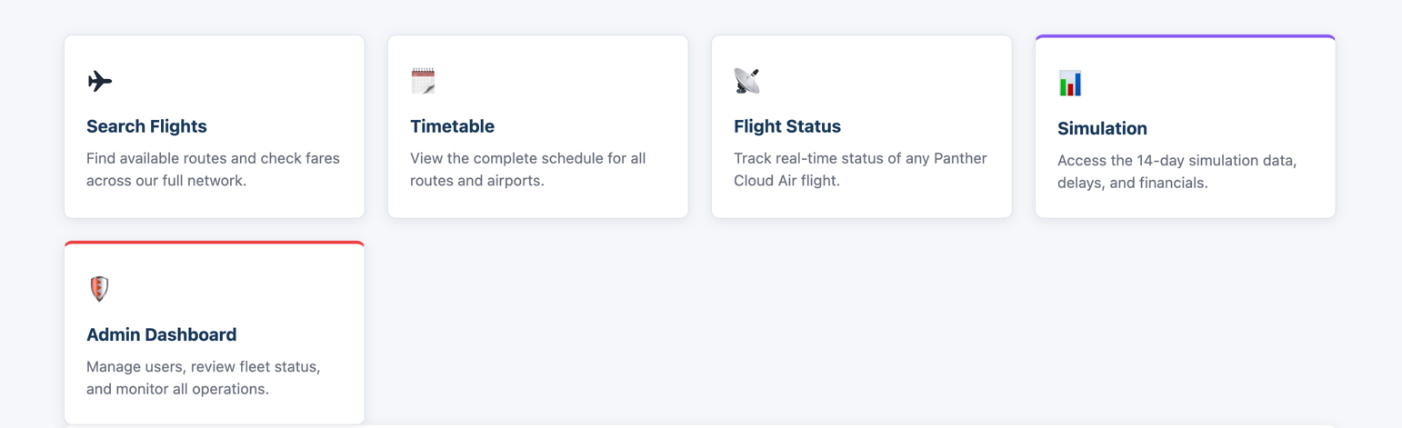
Figure 4: Feature Cards
Below the dashboard, users will find feature cards that provide quick access to the system’s core functions:
- Search Flights
- Timetable
- Flight Status
- Simulation
- Admin Dashboard

Departures Table
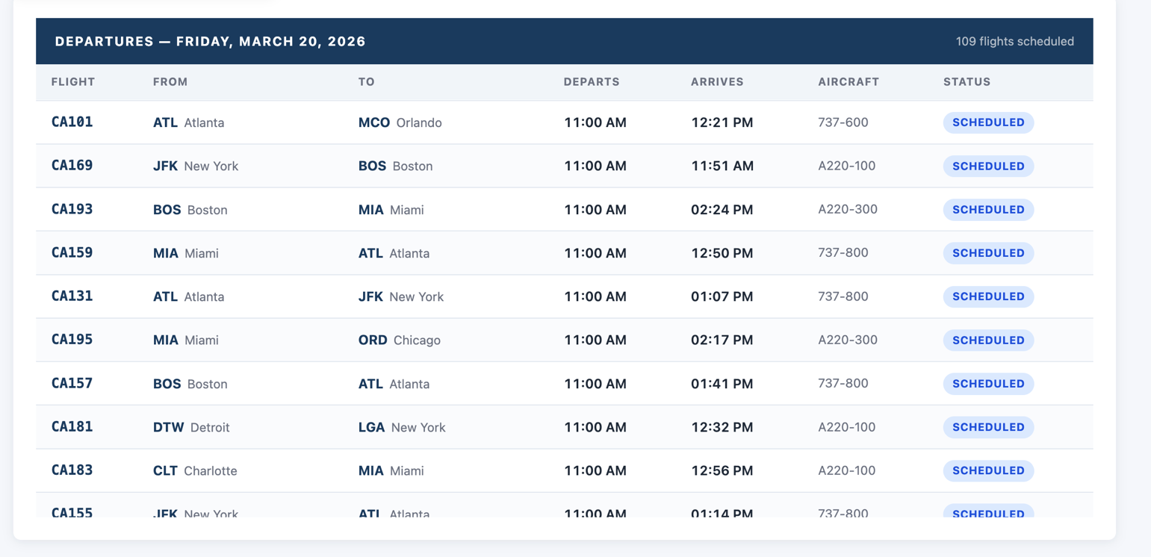
Figure 5: Departures Table
The Departures section provides a detailed list of scheduled flights for the selected date.
Information Included:
- Flight Number
- Origin Airport
- Destination Airport
- Departure Time
- Arrival Time
- Aircraft Type
- Status (e.g., Scheduled)
How to Use:
- Users can scan the table to view all flights for the day
- Helps airline workers manage scheduling and bookings
- Useful for verifying flight details quickly

Search Flights

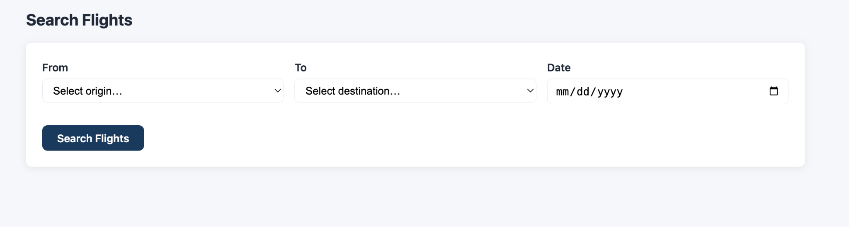
Figure 6: Search Flights
The Search Flights page allows users to find available flights between any two airports in the Panther Cloud Air network, including all major U.S. airports and the New York–Paris route.
This feature can be accessed by selecting Search Flights from the home page or the navigation menu.

How to Search for Flights
Enter Search Criteria
When the page loads, three input fields are displayed:
- From – Select the departure airport from a dropdown list
- To – Select the destination airport from a dropdown list
- Date – Select the desired travel date (mm/dd/yyyy)
Airports are listed using their abbreviation and city name (e.g., ATL – Atlanta).
Submit Search
- After all fields are completed, click the Search Flights button
- The selected route and date will be displayed above the results (e.g., ATL → ORD 03/19/2026)
View Results
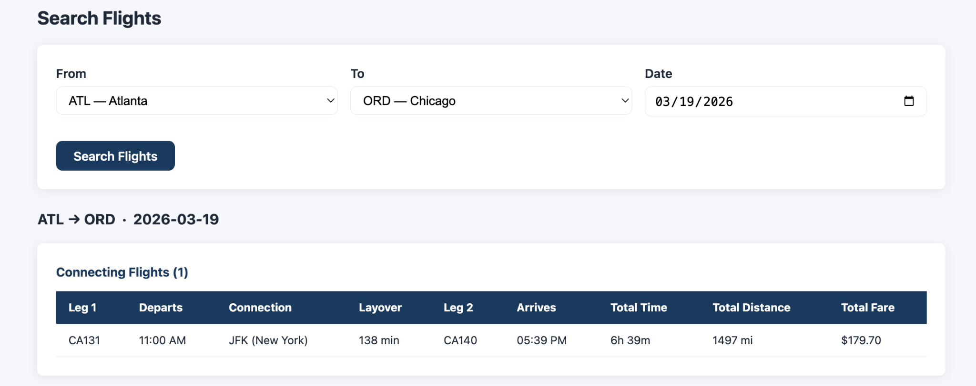
Figure 7: Search Flights Results
If flights are available, results will appear below the search panel.
Each result includes:
- Flight number
- Departure time
- Arrival time
- Total travel time
- Total distance
- Fare
If the route requires a connection, results will appear under a Connecting Flights section showing available options and layover details.
No Results
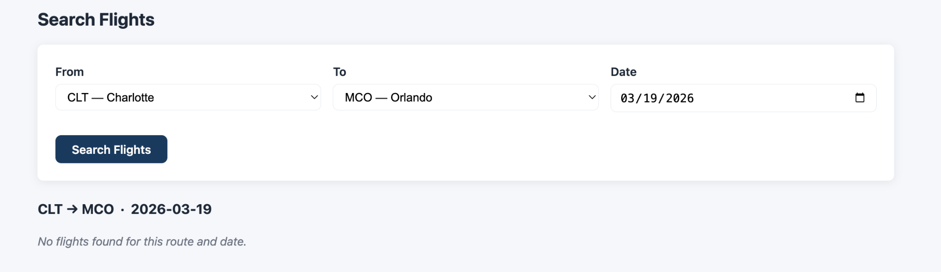
Figure 8: Search Flights No Results
If no flights match the selected criteria, the system will display:
“No flights found for this route and date”

Flight Status

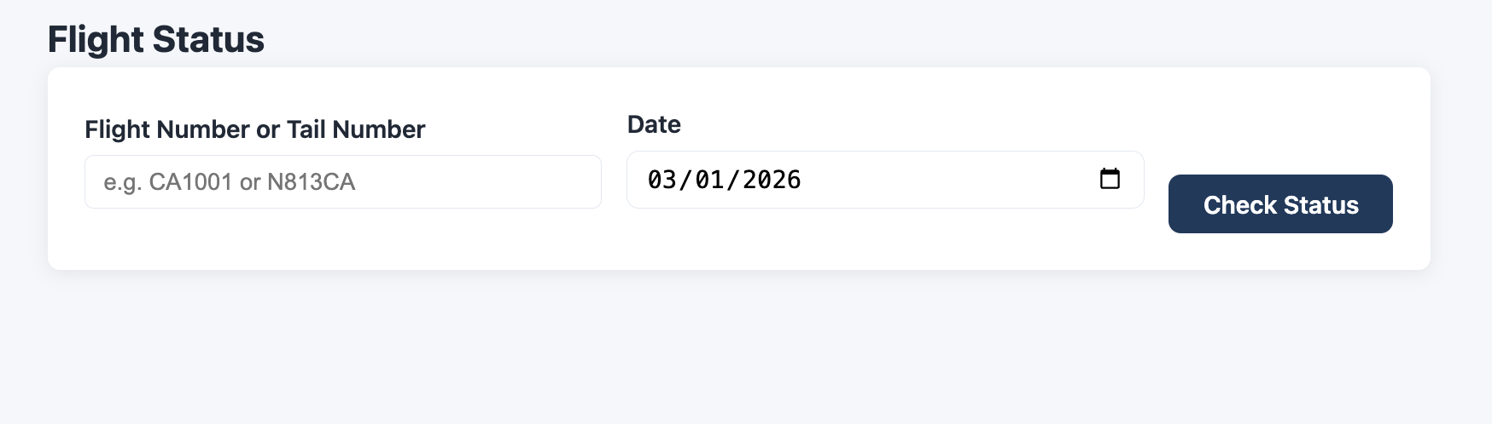
Figure 9: Flight Status
The Flight Status page allows users to check the current status and details of a specific flight.
This feature can be accessed from the home page or the navigation menu.

How to Check Flight Status
Enter Search Information
When the page loads, two input fields are displayed:
- Flight Number or Tail Number – Enter a flight number (e.g., CA165) or aircraft tail number (e.g., N223CA)
- Date – Enter the date of the flight
Submit Request

Click the Check Status button to retrieve flight information
View Results
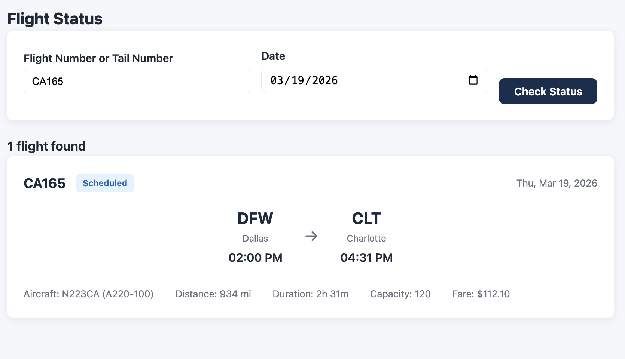
Figure 10: Flight Status Results
If a matching flight is found, the system will display one or more results.
Each result includes:
- Flight number
- Status (e.g., Scheduled)
- Departure airport and time
- Destination airport and arrival time
The status is visually indicated (e.g., blue label for scheduled flights).
No Results
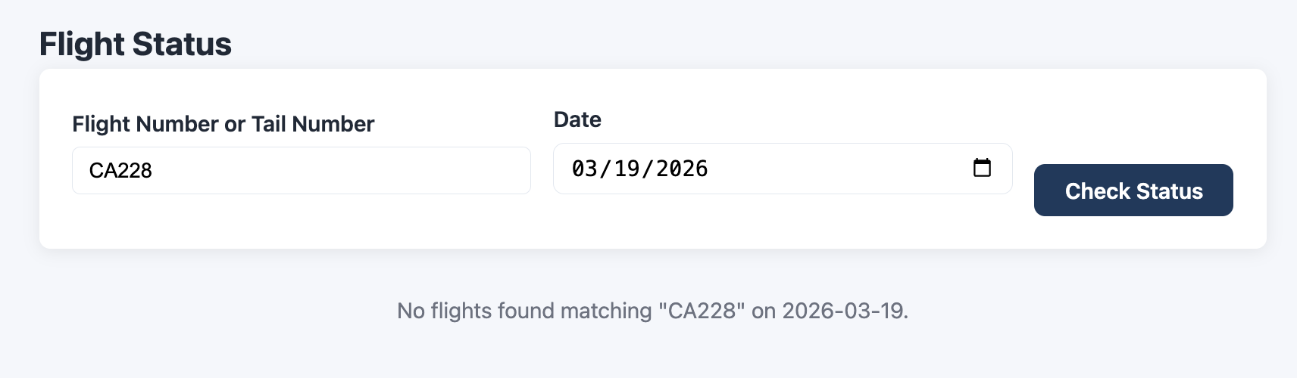
Figure 11: Flight Status No Results
If no matching flight is found, the system will display:
“No flights found for that search”

Timetable

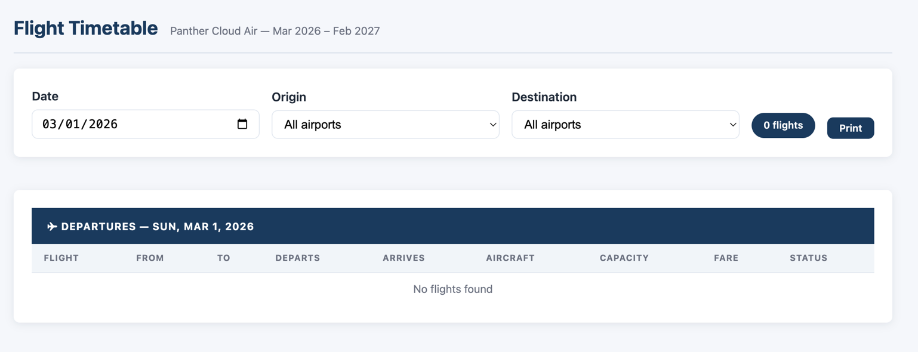
Figure 12: Timetable

The Timetable page allows users to view and filter all scheduled flights across the Panther Cloud Air network.
The timetable displays flight schedules for a selected date, including departure and arrival times, aircraft type, seat capacity, and fare information.
Users can filter results to view specific routes or airports.

How to Use the Timetable
Select Date
- Use the Date field to choose the day you want to view
- The timetable will update to show flights scheduled for that date
Select Origin
- Use the Origin dropdown to filter flights by departure airport
- Selecting “All airports” will display flights from all locations
Select Destination
- Use the Destination dropdown to filter flights by arrival airport
- This can be combined with the origin filter to narrow results
View Flight Results
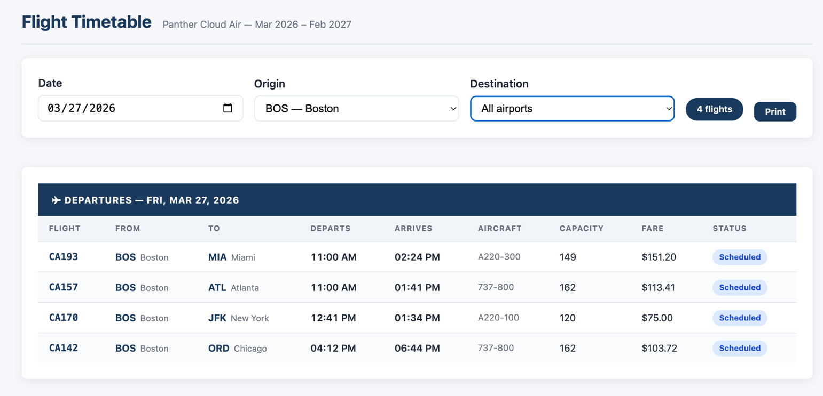
Figure 13:Timetable Results

After selecting filters, the system will display matching flights in the table below.
If no flights match the selected criteria, a message will appear:

“No flights found”
Flight Count
- The system displays the number of flights that match your filters
- This updates automatically as filters are changed
Print Option
- Click the Print button to generate a printable version of the timetable
- This is useful for sharing schedules or offline reference

Flight Information Displayed
Each row in the timetable includes:
- Flight Number – Unique identifier for the flight
- From – Departure airport
- To – Destination airport
- Departs – Scheduled departure time
- Arrives – Scheduled arrival time
- Aircraft – Type of aircraft used
- Capacity – Number of available seats
- Fare – Ticket price for the flight
- Status – Current status (e.g., Scheduled)

Simulation

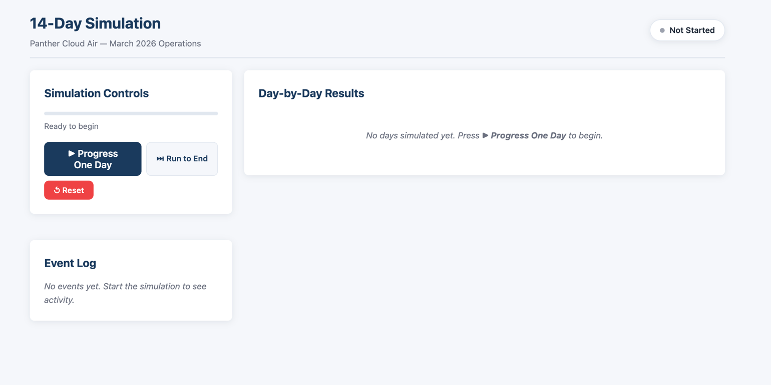
Figure 14: Simulation
The Simulation page allows users to run a 14-day operational simulation of the airline system.
This feature can be accessed from the navigation menu.

Overview
The simulation models:
- Flight scheduling
- Delays and disruptions
- Daily operations over a 14-day period
The system processes events step-by-step or all at once.

Simulation Controls
Users can control the simulation using the following options:
- Progress One Day – Advances the simulation by one day
- Run to End – Runs the full 14-day simulation automatically
- Reset – Resets the simulation back to its initial state

Day-by-Day Results
- This section displays results for each simulated day
- Initially, no data is shown until the simulation begins
- As the simulation progresses, results will populate with operational outcomes

Event Log
The Event Log tracks system activity during the simulation.
Examples include:
- Flight delays
- Cancellations
- System updates
If no simulation has been run, the log will display:
“No events yet. Start the simulation to see activity.”

Admin Dashboard

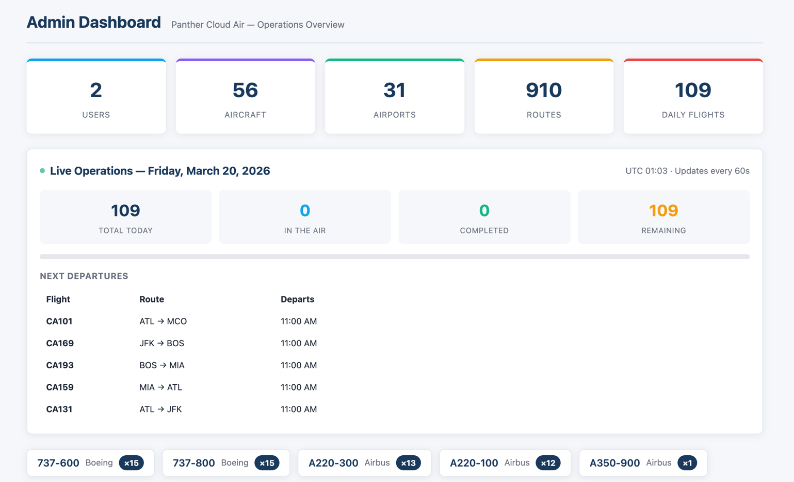
Figure 15: Admin Dashboard
The Admin Dashboard provides administrators with full system visibility and control over users, aircraft, and airport data.
This feature can be accessed through the Admin Dashboard option in the navigation menu.

Overview
At the top of the dashboard, summary cards display key system metrics:
- Total Users
- Total Aircraft
- Total Airports
- Total Routes
- Daily Flights
These metrics give a quick overview of system activity and scale.

Live Operations Panel
The Live Operations section displays real-time system activity for the current day.
Information includes:
- Total flights scheduled
- Flights currently in the air
- Completed flights
- Remaining flights
The system updates automatically at regular intervals.

Next Departures
This section lists upcoming flights with:
- Flight number
- Route (origin → destination)
- Departure time
This allows administrators to quickly monitor near-term activity.

Data Management Tabs
The dashboard includes three main data tabs:
Users
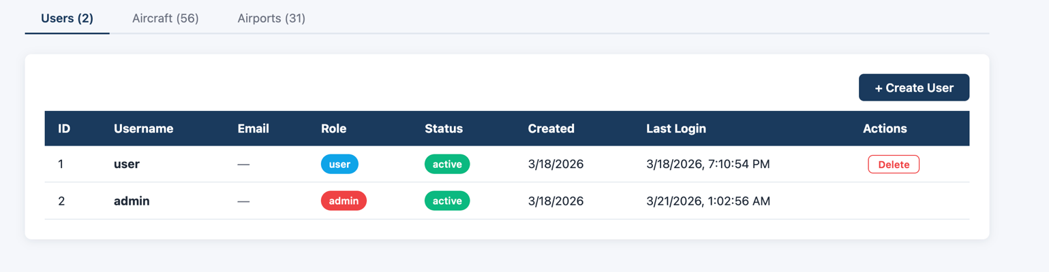
Figure 16: Users Data Management Tab
Displays all system users with the following information:
- User ID
- Username
- Role (user or admin)
- Status (active/inactive)
- Account creation date
- Last login time
Actions:
- Create new user using + Create User
- Delete existing users
Aircraft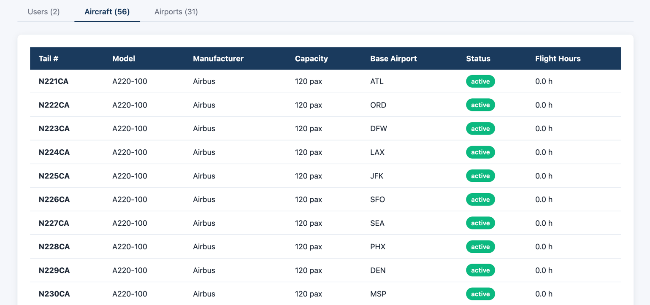
Figure 17: Aircraft Data Management Tab
Displays all aircraft in the system, including:
- Tail number
- Model
- Manufacturer
- Passenger capacity
- Base airport
- Status (active)
- Total flight hours
This allows administrators to monitor fleet distribution and availability.
Airports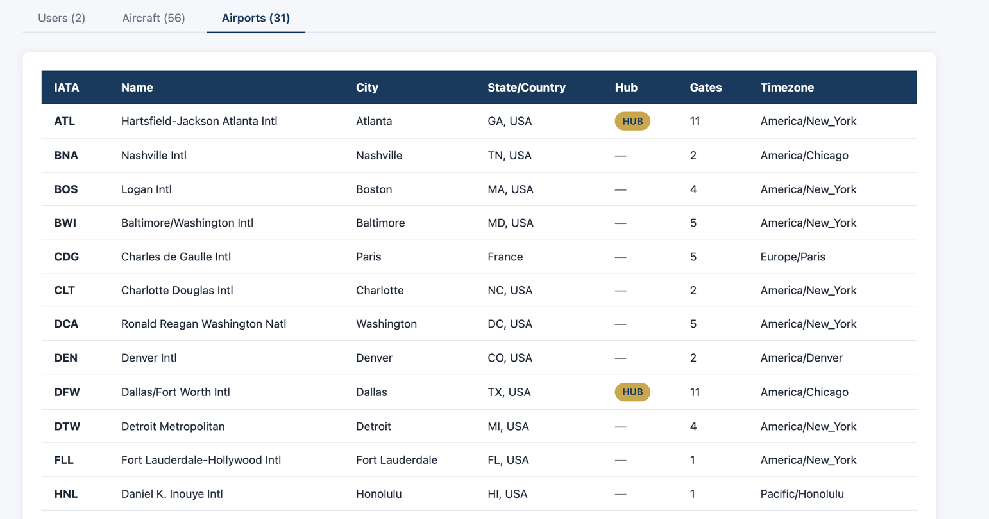
Figure 18: Airports Data Management Tab
Displays all supported airports, including:
- IATA code
- Airport name
- City and location
- Hub designation
- Number of gates
- Time zone
Hub airports are visually labeled for easy identification.

